IN723 Lab 3 BGP Peering

In this lab we will configure basic iBGP & eBGP peering. We look at how to use loopbacks for peering and how to solve next-hop issues.
- Note – This lab cannot be completed in packet tracer (unsupported BGP commands). Use VIRL, GNS3 or the physical lab.
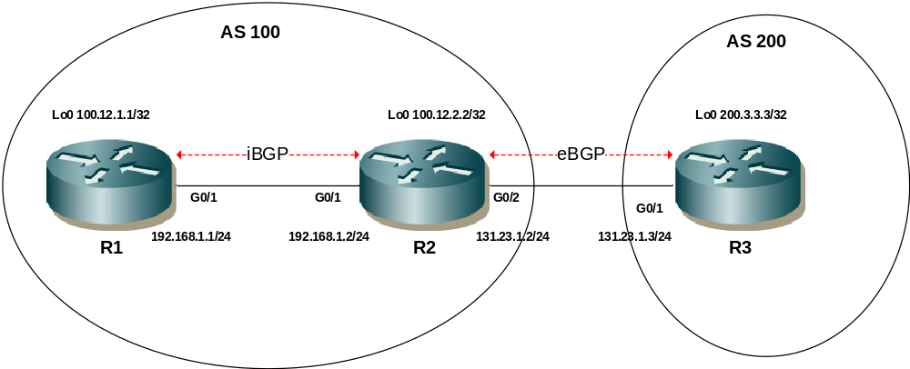
Step 1 - Physical
- Physically cable the lab as per the above diagram using 1841 / 1941 routers and 2690 switches
- There is no specification for which end of each serial link should be DCE

Step 2 – IP addressing
- Configure IP addressing as per the network diagram.
- Ensure to configure the loopback interfaces.

Step 3 – Basic Peering
- Configure fixed router-ids on R1, R2 and R3 using the loopback IP addresses
- Configure EBGP between R2 and R3 using the WAN interfaces for peering
- Configure IBGP between R1 and R2 using WAN interfaces for peering
- Verify peer status with
show ip bgp summary

Step 4 – Configure iBGP peering with loopback addresses
- Configure a static route on R1 pointing to R2s loopback
- Configure a static route on R2 pointing to R1s loopback
- Change the IBGP peering between R1 and R2 to use loopback addresses. Note you need to consider both the source and destination addresses
- Name 2 reasons why IBGP peering using loopback interfaces is a good idea
1
2

Step 5 – Redistribute R1 and R3 loopback
- Advertise the R3 loopback address into BGP using the network statement.
- Redistribute the R1 loopback address into BGP. Use a route-map to match only the loopback interface.
- Can R1 & R3 ping each other’s loopbacks? (source pings from lo0)
- Why not?
Look at the route table and BGP table on both routers to help (hint: check the advertised next hops)

Note: the r code in the bgp table = rib-failure. This indicates that a route with a better admin distance already exists in the route table. This is normal when static routes are used. The bgp prefix will still be advertised to peers if it is marked as best (>).

Step 6 – Next-hop-self
- Configure R2 to advertise itself as the next-hop for BGP prefixes advertised to R1
- Can R1 & R3 ping each other’s loopbacks? (source pings from lo0)

Step 7 – Change EBGP peering to loopbacks with multihop200
- Configure a static route on R2 pointing to R3s loopback
- Configure a static route on R3 pointing to R2s loopback
- Change the EBGP peering between R1 and R2 to use loopback addresses. Remember to consider the update source. In addition you need to change the TTL for EBGP peering (IBGP loopback peering does not need this) using the ebgp-multihop command.

Extension
- Cable an additional Ethernet link between R1 & R2
- Configure floating static routes on R1 and R2 to get to each others loopbacks
- Shutdown the primary path, does the EBGP peering between R1 & R2 stay up?

